**Zhumagali Kanat IT2-2003**

**Practice 4.1 (Composite Data Types)**

1. Within the PL/SQL block create a record to store information about yourself: name, year of birth, place of birth. Output the information to the screen.

DECLARE

TYPE my_information is record (

last_name varchar2(20),

year_of_birth number,

place_of_birth varchar2(20)

);

info my_information;

BEGIN

info.last_name := 'Zhumagali';

info.year_of_birth := 2003;

info.place_of_birth := 'Shymkent';

DBMS_OUTPUT.PUT_LINE('Info about myself: ');

DBMS_OUTPUT.PUT_LINE('Last name: ' ||info.last_name || ', Year of birth: '||info.year_of_birth || ', Place of birth: ' || info.place_of_birth );

END;

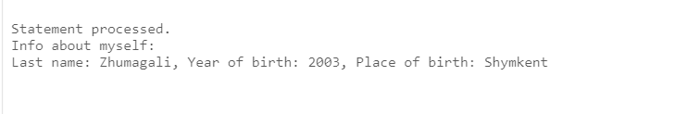

2. Write a PL/SQL block to print information about a given country.

a. Declare a PL/SQL record based on the structure of the countries table.

b. Define a variable countryid and pass the value througha substitution variable.

1. In the executable section, get all the information from the countries table by using countryid. Display selected information about the country. A sample output is shown below.
2. You may want to execute and test the PL/SQL block for the countries with the IDs DE, UK, US.

DECLARE

type countries_info is record(

country_id varchar2(5),

country_name varchar2(50),

region_id number

);

my_country_id varchar2(5);

c_info countries_info;

BEGIN

my_country_id := 'CA';

SELECT country_id, country_name, region_id into c_info from countries where country_id = my_country_id;

DBMS_OUTPUT.PUT_LINE('Country ID: ' || c_info.country_id);

DBMS_OUTPUT.PUT_LINE('Country name: ' || c_info.country_name);

DBMS_OUTPUT.PUT_LINE('Region: ' || c_info.region_id);

END;

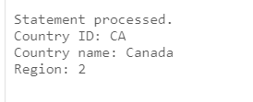

3. Within a PL/SQL block create an INDEX BY table to store the square of the numbers from 1 to 8. Output the result to the screen.

declare

type sq_of_numbers is table of number

index by pls_integer;

squares pls_integer;

sq_table sq_of_numbers;

begin

for squares in 1..8 loop

sq_table(squares) := power(squares, 2);

DBMS_OUTPUT.PUT_LINE(squares || '^2 = ' || sq_table(squares));

end loop;

end;

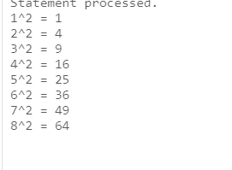

4. Create a PL/SQL block to retrieve the names of some departments from the departments table and print each department name on the screen, incorporating an INDEX BY table. Using a loop, retrieve the names of 10 departments and store the names in the INDEX BY table. Start with department_id 10. Increase deptno by 10 for every iteration of the loop. The following table shows the department_id for which you should retrieve the department_name and store in the INDEX BY table. Using another loop, retrieve the department names from the INDEX BY table and display them.



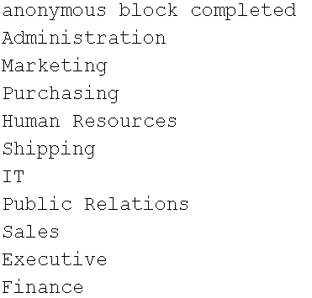

declare

type departments_table is table of departments.department_name%type index by pls_integer;

d_index pls_integer;

d_table departments_table;

begin

d_index := 10;

while d_index <=100 loop

select department_name into d_table(d_index) from departments where department_id = d_index;

DBMS_OUTPUT.PUT_LINE(d_table(d_index));

d_index := d_index + 10;

end loop;

end;

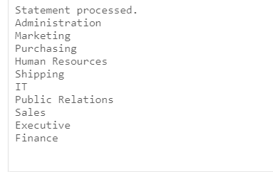

**Practice 4.2 (Explicit Cursors)**

1. Create a PL/SQL block that determines the top *n* salaries of the employees.

* + - 1. Create a table top_salaries with one column salary of the type NUMBER(8, 2).
      2. Declare a number *n* that represents the number of top *n* earners from the employees table.
      3. Declare a variable sal of type employees.salary.
      4. Declare a cursor, emp_cursor, that retrieves the salaries of employees in descending order. Remember that the salaries should not be duplicated.
      5. In the executable sectio n, open the loop and fetch top *n* salaries and insert them into top_salaries table. You can use a simple loop to operate on the data. Also, try and use %ROWCOUNT and %FOUND attributes for the exit condition.
      6. After inserting into the top_salaries table, display the rows with a SELECT statement. The output shown represents the five highest salaries in the employees table.

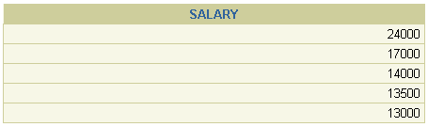

* + - 1. Test a variety of special cases, such as *n* = 0 or where *n* is greater than the number of employees in the employees table. Empty the top_salaries table after each test.

CREATE TABLE top_salaries (

salary number

);

drop table top_salaries;

declare

n number;

sal employees.salary%type;

cursor emp_cursor is select salary from employees order by salary desc;

begin

n := 6;

open emp_cursor;

for i in 1..n loop

fetch emp_cursor into sal;

exit when emp_cursor%rowcount >=n or emp_cursor%NOTFOUND;

insert into top_salaries(salary) values(sal);

end loop;

end;

select salary from top_salaries;

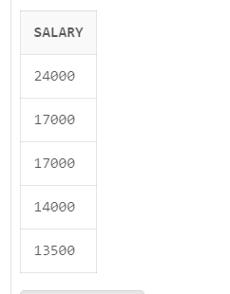

2. Create a PL/SQL block that outputs all employees from the department 60 and with the salary more than 5000.

declare

cursor dep_table is select last_name from employees where department_id = 60 and salary > 5000;

last_name employees.last_name%type;

begin

open dep_table;

loop

fetch dep_table into last_name;

exit when dep_table%notfound;

DBMS_OUTPUT.PUT_LINE('From department 60 and salary > 5000 is ' || last_name);

end loop;

end;

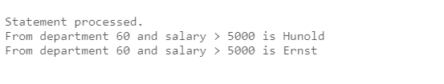

3. Rewrite the script of the task 2 using Cursor FOR Loop.

declare

cursor dep_table is select last_name from employees where department_id = 60 and salary > 5000;

last_name employees.last_name%type;

begin

for dep_record in dep_table loop

DBMS_OUTPUT.PUT_LINE('From department 60 and salary > 5000 is ' || dep_record.last_name);

end loop;

end;

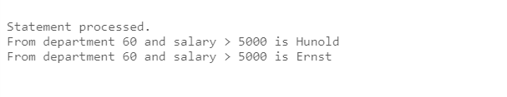

4. Create a PL/SQL block that does the following:

* + - 1. Define a variable deptno to provide the department ID.
      2. Declare a cursor, emp_cursor, that retrieves the last_name, salary, and manager_id of the employees working in the department specified in deptno.
      3. In the executable section use the cursor FOR loop to operate on the data retrieved. If the salary of the employee is less than 5000 and if the manager ID is either 101 or 124, display the message <<*last_name*>> Due for a raise. Otherwise, display the message <<*last_name*>> Not due for a raise.
      4. Test the PL/SQL block for the following cases:



declare

deptno departments.department_id%type;

cursor emp_cursor is select last_name, salary, manager_id from employees where department_id = deptno;

begin

deptno:= 20;

for emp_record in emp_cursor loop

if (emp_record.salary < 5000 and (emp_record.manager_id = 101 or emp_record.manager_id = 124)) then DBMS_OUTPUT.PUT_LINE(emp_record.last_name || ' Due for rise');

else DBMS_OUTPUT.PUT_LINE(emp_record.last_name || ' Not due for a raise');

end if;

end loop;

end;

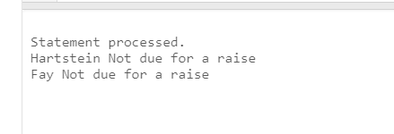

5. Write a PL/SQL block, which declares and uses cursors with parameters. In a loop, use a cursor to retrieve the department number and the department name from the departments table for a department whose department_id is less than 100. Pass the department number to another cursor as a parameter to retrieve from the employees table the details of employee last name, job, hire date, and salary of those employees whose employee_id is less than 120 and who work in that department.

* + - 1. In the declarative section, declare a cursor dept_cursor to retrieve department_id, department_name for those departments with department_id less than 100. Order by department_id.
      2. Declare another cursor emp_cursor that takes the department number as parameter and retrieves last_name, job_id, hire_date, and salary of those employees with employee_id of less than 120 and who work in that department.
      3. Declare variables to hold the values retrieved from each cursor. Use the %TYPE attribute while declaring variables.
      4. Open the dept_cursor, use a simple loop and fetch values into the variables declared. Display the department number and department name.
      5. For each department, open the emp_cursor by passing the current department number as a parameter. Start another loop and fetch the values of emp_cursor into variables and print all the details retrieved from the employees table. **Note:** You may want to print a lineafter you have displayed the details of each department.Use appropriate attributes for the exit condition. Also determine whether a cursor is already open before opening the cursor.
      6. Close all the loops and cursors, and end the executable section. Execute the script.

The sample output is shown below.

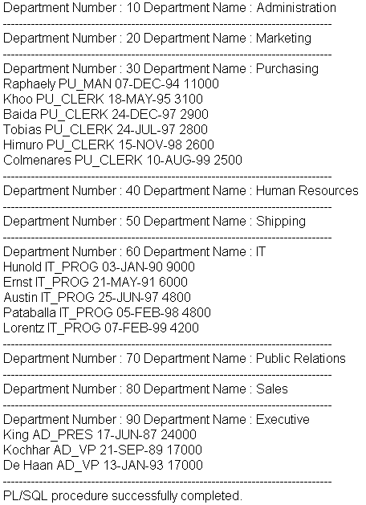

declare

cursor dept_cursor is select department_id, department_name from departments where department_id < 100;

cursor emp_cursor (deptno number) is select last_name, job_id, hire_date, salary from employees where employee_id < 120 and department_id = deptno;

dep_id departments.department_id%type;

dep_name departments.department_name%type;

emp_last_name employees.last_name%type;

emp_job_id employees.job_id%type;

emp_hire_date employees.hire_date%type;

emp_salary employees.salary%type;

begin

open dept_cursor;

loop fetch dept_cursor into dep_id, dep_name;

exit when dept_cursor%notfound;

DBMS_OUTPUT.PUT_LINE('dep id: ' || dep_id || ' dep name ' || dep_name);

open emp_cursor(dep_id);

loop fetch emp_cursor into emp_last_name, emp_job_id, emp_hire_date, emp_salary;

exit when emp_cursor%notfound;

DBMS_OUTPUT.PUT_LINE('Last name: ' || emp_last_name || 'Job id: ' || emp_job_id || 'Hire date: ' || emp_hire_date || 'Salary: ' || emp_salary );

end loop;

close emp_cursor;

end loop;

close dept_cursor;

end;

